**INTERPRETATION OF SALES DATA**

* ***Objective****:*

"This report presents an analysis of the sales performance of Jan 2024. Key insights include a 10% increase in overall sales, significant regional performance differences, and a notable product growth product category. The analysis suggests that marketing campaigns in West Region and product diversification in the Product category were key drivers of success."

* ***Data Overview***

"Data used for this analysis was sourced from the company's sales database covering the period of January 1st to January 31st, 2024. Key metrics included Total Sales revenue, Top-selling Products, Sales by Region, and Customer Segmentation

* ***Methodology***

Get the CSV data file and done the cleaning in Power BI editor and used DAX to create measure

**"The sales growth percentage was calculated using the following formula:**

DAX

Copy code

Sales Growth Percentage = DIVIDE(([Current Period Sales] - [Previous Period Sales]), [Previous Period Sales])

* ***Key Insights and Results***

"The overall sales for January 2024 grew by 10%, driven primarily by West Region in Product ID P004. while South Region experienced a decline of minimum 50%. In Product ID P001

* ***Analysis and Visualizations***

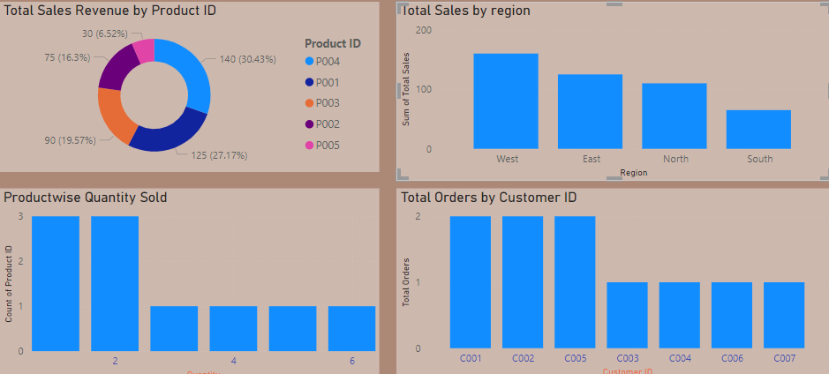

* ***Recommendations***

"To capitalize on the strong performance of the Product ID, we recommend increasing inventory and focusing marketing efforts in this area for Q2. For South Region further analysis is needed to understand why sales declined, and corrective measures should be implemented to increase engagement."

* ***Limitations***

"This analysis was limited by the absence of complete customer feedback data, which may affect the understanding of the factors driving sales performance in South Region."

* ***Conclusion***

"Overall, the January sales performance indicates strong growth in certain regions and categories. While South Region have underperformed, there are actionable steps that can be taken to address these areas and sustain the overall upward trend in sales."